**LAGOS STATE GOVERNMENT**

**Y2023 CITIZENS’ BUDGET**

1. **Introduction**
   1. **Lagos State Budget**

Chapter 5 Section 121 of the 1999 Constitution, requires, the Governor to submit an annual budget proposal (Appropriation Bill) for enactment into law by the House of Assembly. After the passing of the appropriation Bill into Law, it is assented to by the Governor and becomes an Appropriation Law. Hence, the responsibility for the State Budget is between the Executive and Legislative arms of the Government.

The Lagos State Governor, Mr. Babajide Olusola Sanwo-Olu, presented the Y2023 Budget proposal (Appropriation Bill) tagged **"Budget of Continuity"** to the State House of Assembly on Thursday, 27th October 2022 and signed the bill into law (Appropriation Law) on Friday, January 27th, 2023.

* 1. **The Objectives of Y2023 Budget**

**Effective Governance**

**Thriving Economy**

**Human-Centric City**

**Modern Infrastructure**

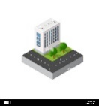

That Lagos will have reliable and sufficient infrastructure that meets the needs of a 21st century city.

That every Lagosian will have access to affordable and world-class education, healthcare, and social services.

That Lagos will have a supportive and enabling environment that creates opportunities for all Lagosian.

That Lagos will have a robust, healthy and growing economy with adequate jobs and strategic investments to sustain growth.

1. **Lagos Socio-Economic Profile**
   1. **Lagos Demographics**

* 1. **Socio-Economic Indices**

1. **Setting Policy Target**

The Lagos State Government prepares the Budget in line with THEME’s Agenda initiative and direction for the State. The budget serves as a policy tool for achieving the short, medium, and long-term development goals also taking cognizance of the 17 Sustainable Development Goals and the State Development Plan (LSDP Y2023-2052).

* 1. **The Alignment of the THEMES Agenda with the 17 Sustainable Development Goals**

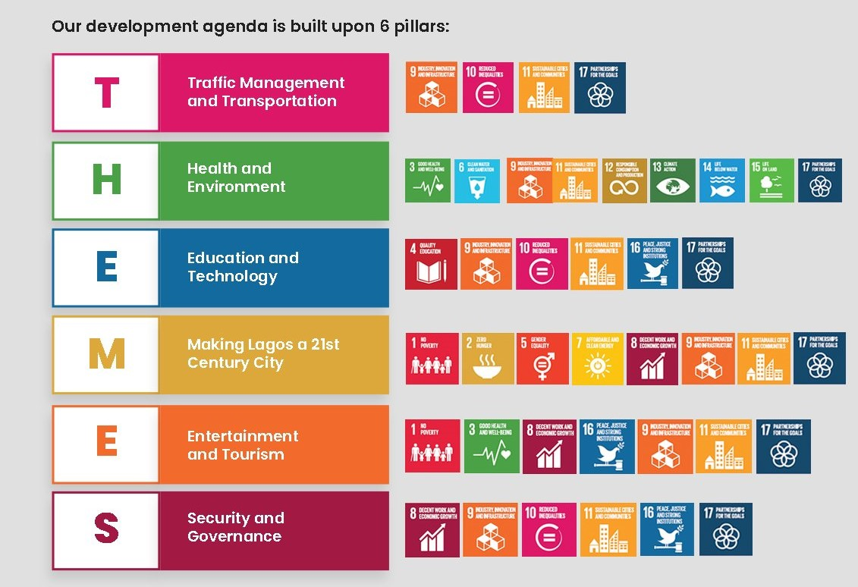

* 1. **The Lagos State Development Plan (LSDP) (Y2023-2052).**
     1. **Vision and Mission**

**MISSION**

**VISION**

|  |  |
| --- | --- |
|  | Lagos State’s Vision is to Become Africa’s Model Megacity and Financial Hub that is Safe, Secure, Functional and Productive. |
|  | **The Mission** is to Eradicate Poverty and Promote Economic growth Through Infrastructure Renewal and Development. |

* 1. **The Linkage between Lagos State Development Plan (LSDP) and Budget**

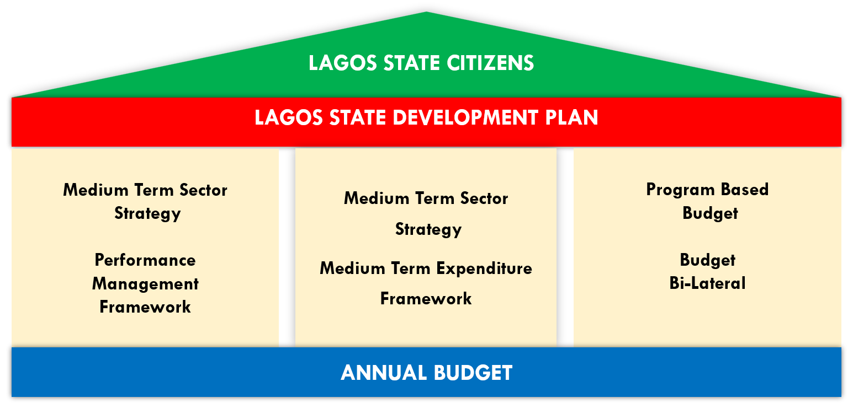

* 1. **Linkages between LSDP, MTSS, PMR and Budget.**

LSDP primarily deals with the long-term plans policies and strategies of government while Medium-Term Sectoral Strategy (MTSS) focuses on the short/ medium term plans that are drawn from the LSDP which then serves as the foundation for creating annual budgets.

The Performance Management Report represents the status of projects and programmes (drawn from the medium-term strategy plans) through monitoring and evaluating actions that will aid decision-making during budget preparation.

* 1. **Developing the Strategy through the Medium-Term Fiscal Framework**

The Y2023 Budget was prepared in line with the Fiscal Responsibility Act of 2007. The fiscal framework provides information on the expected revenue, spending, borrowing, and fiscal balance (deficit or surplus) for three (3) fiscal years (2023-2025).

The Revenue (where the money comes from) and expenditure (where the money is spent) make up the fiscal framework which is made on the following assumptions:

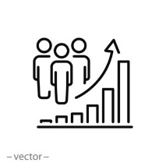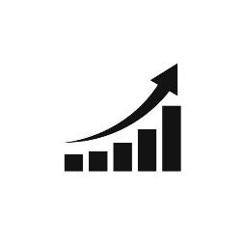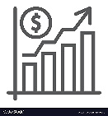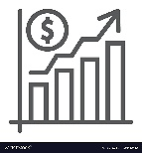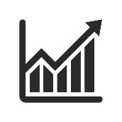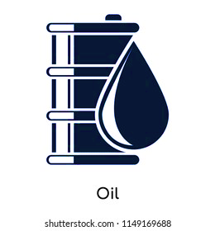

**2023 – 2025 MTBF Assumptions**

**Economic Indices Projections Economic Indices Projections**

**2.55%**

**Population Growth Rate**

**Population**

**Lagos Nominal GDP (Estimated)**

**Inflation Rate (State Figure)**

**Lagos GDP Growth Rate**

**Inflation (national, percent, annual average)**

**GDP growth (national, percent annual change)**

**Exchange Rate**

**Oil production (national, mbpd)**

**Oil Price**

**$100**

**7.12%**

**1.5 /Bbl**

**18.80%**

**$420**

**NGR/USd**

**32.139 trillion**

**11.3%**

**28,698,**

**203**

**13.10%**

1. **Budgeting**
   1. **Budget Definition**

A budget is a financial document prepared by the government that shows expenditures (overhead, personnel, and capital) and expected Revenues (internally generated revenue, dedicated revenue, investment income, capital receipts, and federal transfer) for a fiscal year.

* 1. **Budget Components**

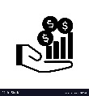

**Revenue:**

How much money will be collected and how it will be collected in a year.

**Major Heads of Revenue**

Internally Generated Revenue, Capital Receipt and Federal Transfers

**Expenditure:**

How much money to be spent in a year, and what to spend the money on

**Major Heads of Expenditure**

Recurrent, Capital, Debt Services and Repayment

**Financing/Debt Service**

When the expenditure is more than the revenue earned, the government must find the financial resources (borrow) to pay for this additional spending. This can be classified into:

• Internal Debt (Money borrowed within Nigeria)

• External Debt (Money borrowed outside Nigeria)

When Principal and interest are paid on the Debts, it is referred to as Debt Service.

* 1. **The Budget Cycle**

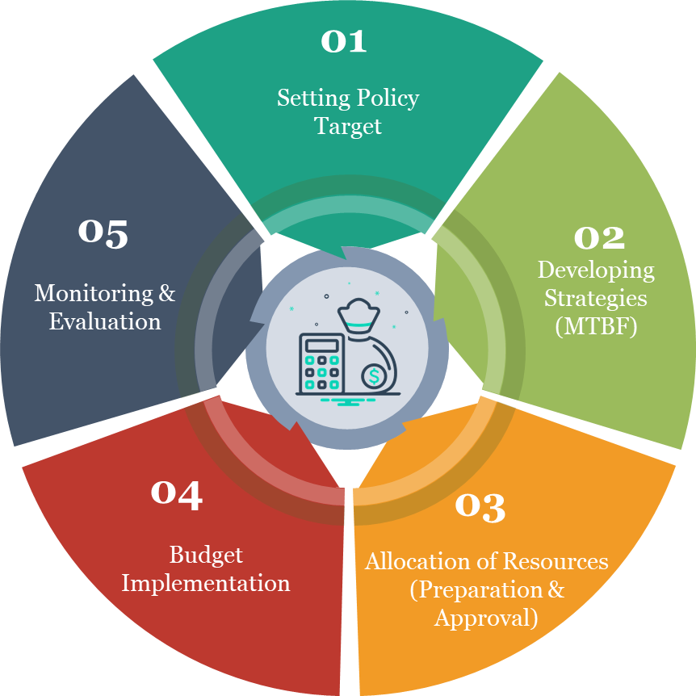

* 1. **Budget Preparation and Approval**
     1. **Citizens’ Engagement (Consultative Forum)**

The budget preparation is inclusive and participatory, the stakeholders are given the opportunity to give their input and buy-in through various interactive fora. The participation of the stakeholders which include the organized business sector, civil society, traditional leaders, and the public sector makes the budgeting process accessible, transparent, and open to the public.

* + 1. **The Budget Call Circular and Bilateral Discussion**

The Budget Call circular provides explicit instructions on how MDAs should develop and submit their estimates within the parameters of the State’s resources. During the bilateral meetings, MEPB ensures that MDAs stay within their figures and in accordance with Government aims and priorities.

1. **Y2023 Budget at a Glance**

|  |  |  |
| --- | --- | --- |
| **Lagos State Budget 2023** |  | |
| **Budget Title: Budget of Continuity** |
|  |
| **General Framework** |
|  |
| **Budget Line Item** | **2023 Approved Budget Naira** | **2023 Approved Budget** |
| Total Budget Expenditure | 1,768,014,155,284 | 1.768 |
| Total Budget Revenue and Grants | 1,417,603,633,010 | 1.417 |
| Budget Deficit | 350,410,522,273 | 0.350 |
| Total Budget Financing | 350,410,522,273 | 0.350 |
| Financing Gap | 0.0 | 0.0 |
| **Y2023 Budget Size** | **N1,768,014,155,284** | |

* + 1. **Where the Money Comes from (Funding)?**

***Revenue:*** Revenue is all the amount of money the government believes it will collect during the year.



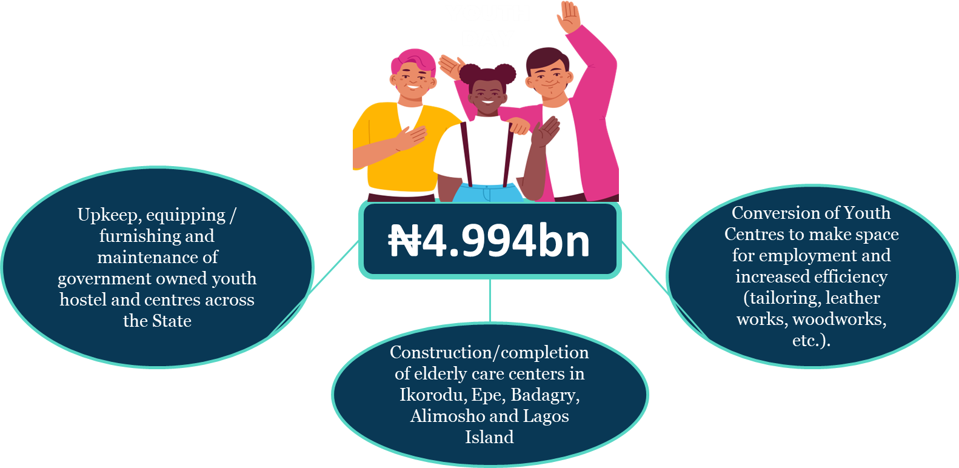

* 1. **Grants**

A grant is defined as any support with Financial Implication (kind or cash), extended by any Organization i.e. public body, charitable foundation, to an individual, government, non-profit organization or another entity for a specific purpose without an interest. Grants can either be foreign or domestic and are usually for a particular project or program with a specified list of expenditure.

|  |  |
| --- | --- |
| **Lagos State Budget 2023** |  |
| **Budget Title: Budget of Continuity** |  |
| **How will the Government source the grants?** |  |
| **Domestic Grants** | **2023 Budget Target** |
| **Project/Donor** | **Amount Naira** |
| Growth Enhancement Support Scheme (GESS) | 256,450,733 |
| National Programme for food Security | 127,008,000 |
| LASU: TETFUND | 247,088,000 |
| UBEC Grant | 1,388,553,446 |
| TETFUND - OTHERS | 207,416,800 |
| Social Proctection - State Coordination Unit (SOCU) | 1,750,000,000 |
| **Total Domestic Grants** | **3,976,516,979** |
| **Foreign Grants** | **2023 Budget Target** |
| **Project/Donor** | **Amount Naira** |
| Sustainable Mobility | 7,000,000 |
| LASG EDU-TRUST FUND | 2,985,000,000 |
| LASU: AFRICAN CENTRE OF EXCELLENCE | 1,909,512,600 |
| SFTAS | 3,000,000,000 |
| Lagos State Coconut Value Chain Development in collaboration with FAO | 1,250,000,000 |
| Lagos State Agric Development Authority | 3,000,000 |
| Circular Economy Initiative | 600,000,000 |
| Supporting Lagos State Universal Health Coverage through Primary Health Care Revitalization | 827,322,420 |
| Youth Power Ecosystem 4 Adolescent Health (YPE4AH) | 1,072,500,000 |
| Hacey Health Initiative | 45,511,805 |
| ICHSSA 2 Project | 8,077,975 |
| Development of electronic HEFAMAA(e-HEFAMAA) Platform | 44,910,055 |
| State Cancer Control Program | 10,458,000 |
| SOML P for R | 2,156,408,060 |
| Malaria diagnostic testing and conditional subsidies to target ACTs in the retail sector: The TESTSMART Trial | 844,797,655 |
| TB, Leprosy and Buruli Ulcer Control Program (TB-LON 3 Project) | 197,647,070 |
| Support to improve maternal and newborn health | 507,250,000 |
| Community Focused approach to increase access to PPFP services in High Home delivery settings in Nigeria (PoPCare) | 2,074,447,220 |
| Accelerating TB Case Notification in Lagos State | 6,309,641,140 |
| Performance Monitoring for Action (PMA) | 124,500,000 |
| State -led Strategic Purchasing for Family Planning (SP4FP) | 2,537,500,000 |
| Supply Chain Support to Lagos State | 124,500,000 |
| Technical Support Unit (TSU 2.0) | 126,808,230 |
| Several activities aimed at supporting the health system at all levels to have strengthened organizational capacities and systems to provide services for prevention and treatment of HIV in women, children, adolescents, and young people, including in emergencies | 12,450,000 |
| Community support systems are strengthened to promote timely uptake of an integrated package of HIV services by pregnant women, their infants, partners and families, and by adolescents | 4,980,000 |
| Children, adolescents and women have equitable access to and use improved and quality, high-impact maternal, neonatal and child health interventions and adopt healthy life practices. | 30,556,035 |
| Strengthening Resilient and Sustainable Systems for Health in Lagos State/GIZ | 12,450,000 |
| UNITAID funded Secondary Prevention of Cervical Cancer using optimal screening and treatment models | 1,909,000,000 |
| World bank Co-prep to LSMOH. | 1,307,564,953 |
| Strengthening Resilient and Sustainable Systems for Health in Lagos State | 662,469,292 |
| Lagos State Technical and Vocational Education Board | 3,096,696,554 |
| Youth Agric Training | 2,500,000 |
| Educate a Child | 1,350,000,000 |
| Water Corporation Support | 12,750,000,000 |
| **Total Foreign Grants** | **47,905,459,064** |

* + 1. **Financing Sources**



* 1. **Loans**

When earnings and grants are insufficient to cover all the budget's expenses, the government typically borrows money to finance its annual budget through loans. A loan is money borrowed in exchange for repayment of the principal amount of the loan plus interest.

* + 1. **Why Does Government Borrow Money?**

A balanced budget is one in which all the year's revenues are equal to the expenditure. The budget is surplus if they plan to spend less than the anticipated revenue. The budget is in deficit when the government wants to spend more money than they expect in revenue. When a budget deficit is projected, the government must find a way to finance it; this is done by borrowing money or by selling off government property. The Federal government, multilateral organizations, banks, and investors on the capital market are all possible sources of borrowing.

* + 1. **Where the Money Goes (Expenditure)**

**Expenditure:**  This is how the government plans to spend on behalf of the citizens. Government expenditure has two main categories namely; Recurrent and Capital. Lagos state strives to achieve prudent and equitable resource management through a budget that spends more on capital items than it’s recurrent.



* + - 1. **Y2023 Capital : Recurrent Ratio.**

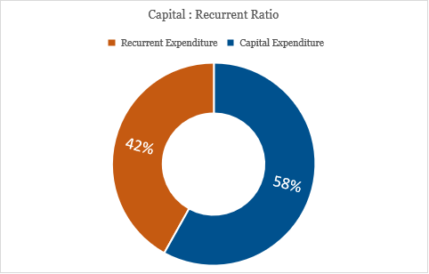

* + - 1. **CapitalExpenditure**

The capital expenditure budget is broken down into projects the government plans to fund and carry out under various MDAs each year. Top Capital Projects are those investments that attract more funding than others. Some of these projects are tabulated below:



* 1. **Function Group Allocation**

The Y2023 Budget Size Function Group **Disaggregation** and percentage reflects Government priorities, sustenance and needs assessment. The analysis is as shown below:



* 1. **Trend Analysis of the Budget Performance (2013-2022)**

|  |  |  |  |
| --- | --- | --- | --- |
| **YEAR** | **BUDGET SIZE (Nbn)** | **ACTUAL PERFORMANCE Nbn** | **% PERF** |

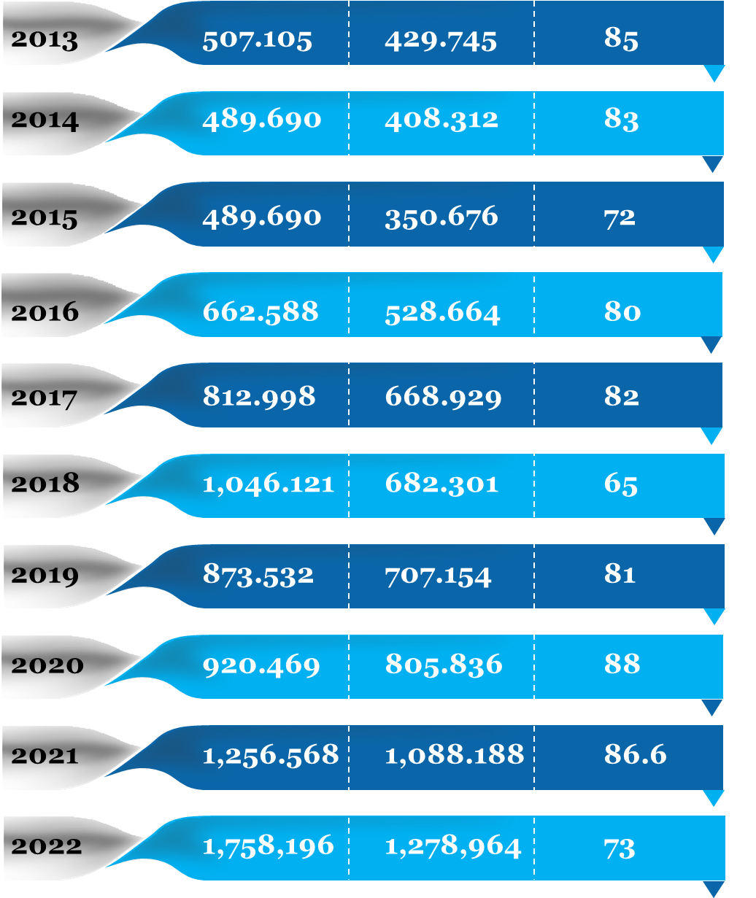

1. **Key Deliverables of the Budget of Continuity** 
   1. **Roads and Other Infrastructures**

A budgetary provision of N148.564bn is provided for the Construction and maintenance of roads and the development of infrastructure along the coastline areas to curb the ocean surge and protect lives and properties within the State.

The provision is to cater for the under-listed projects among others:

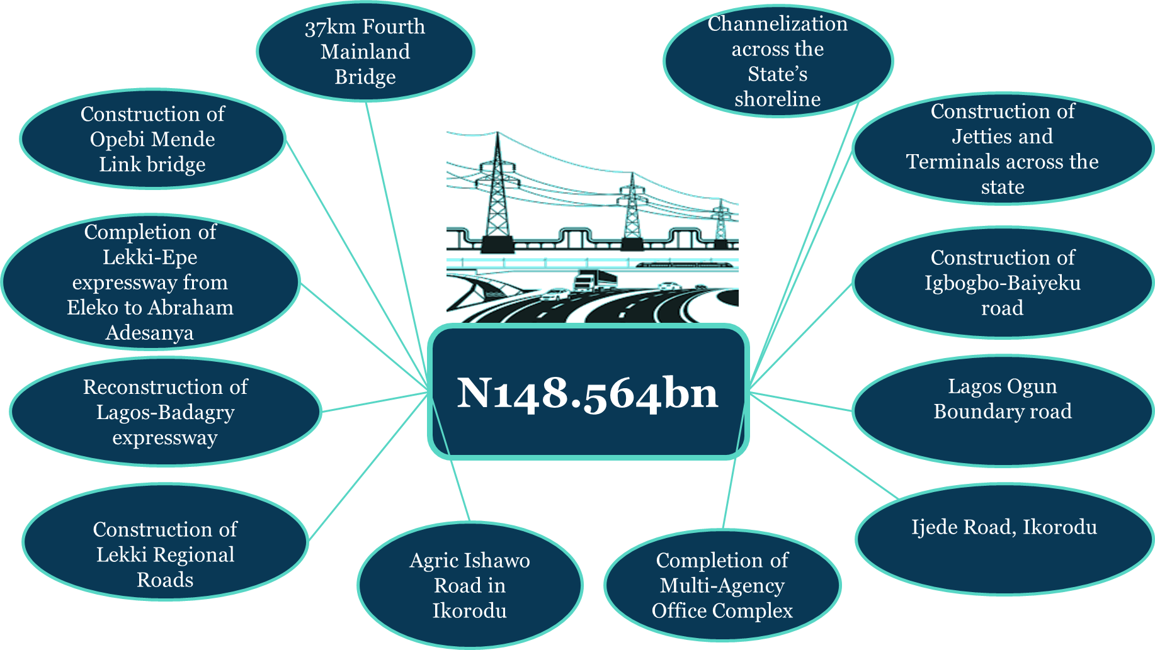

* 1. **Traffic Management/Transportation**

A total sum of ₦165.801bn was budgeted under the transportation family for some of the following projects;

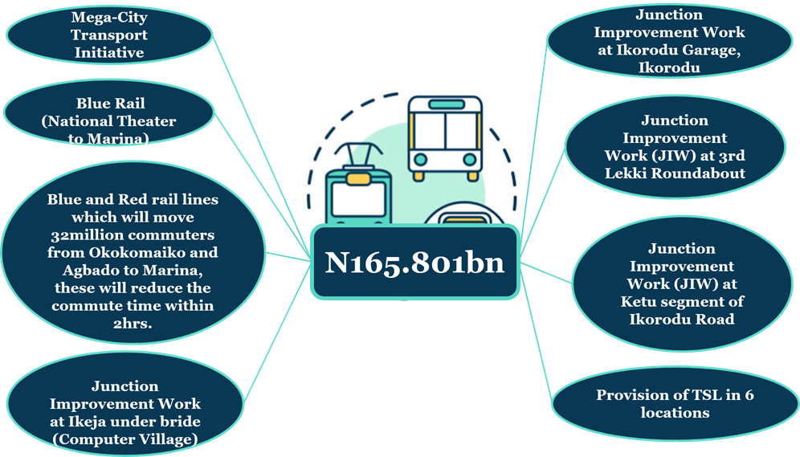

* 1. **Education**

The total sum of ₦156.745bn has been approved for the Education sector to accommodate the underlisted projects/programmes amongst others:

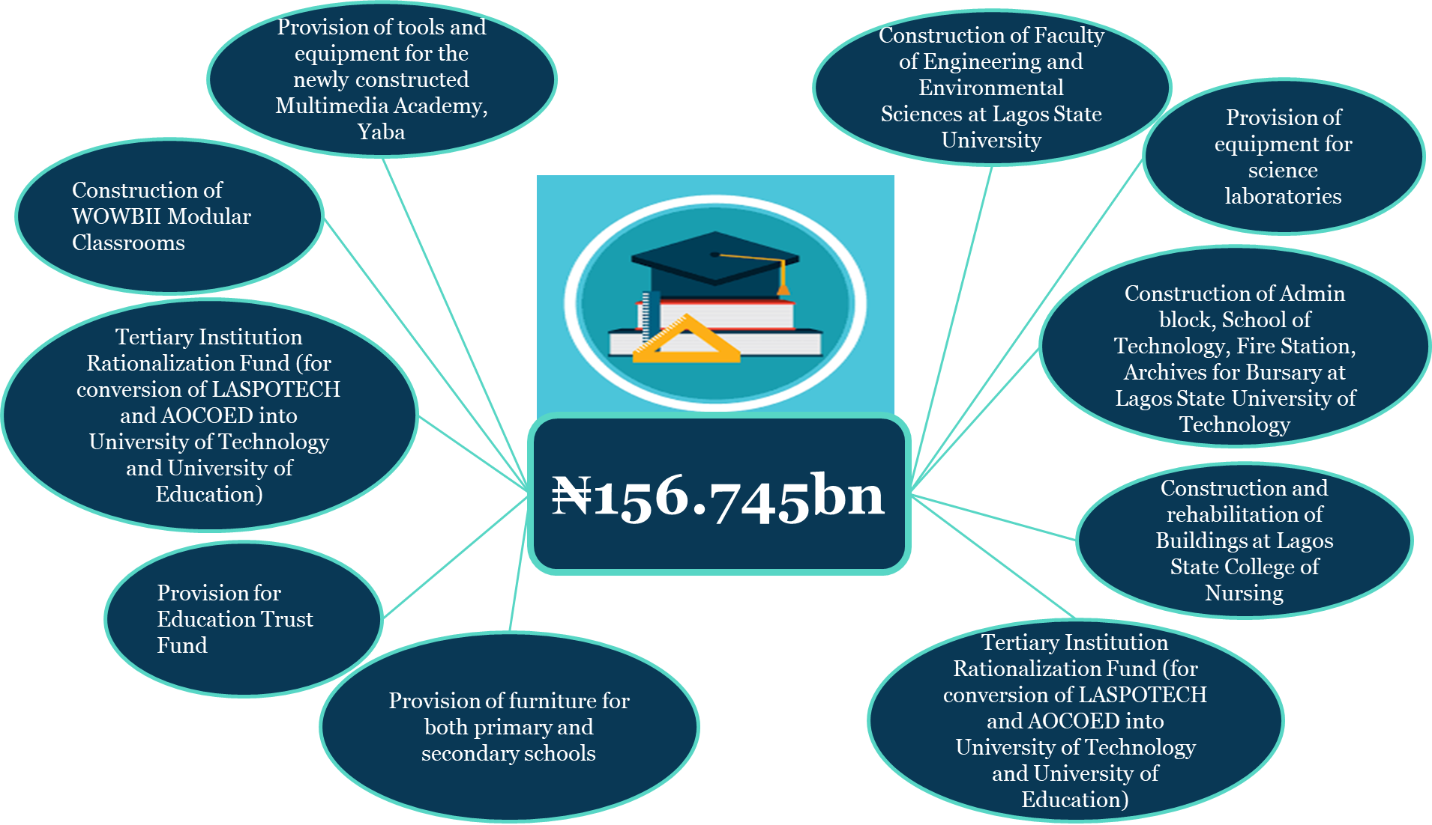

* 1. **Science and Technology**

The sum of ₦35bn has been allocated for building & upgrading of IT Infrastructure Statewide (Smart City Projects), E-GIS Land automation system, New data Center project, Eko Excel Project, ease of tax payment, Levies and Other Revenue enhancement initiatives.

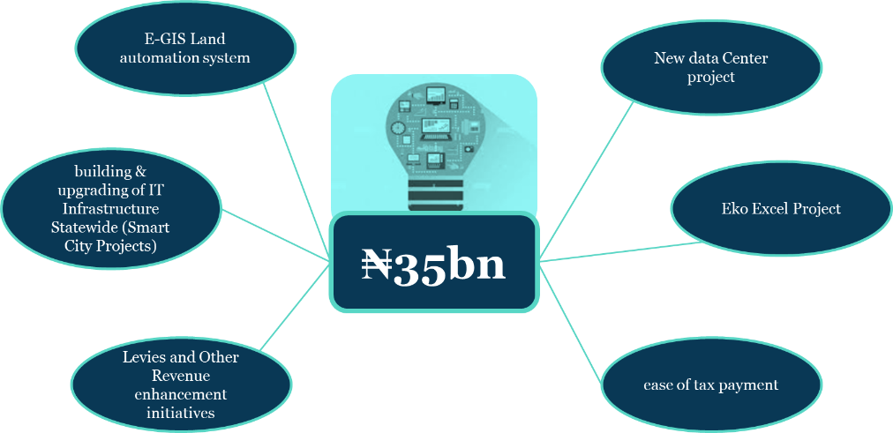

* 1. **Health**

A total sum of ₦149.061bn is invested for Continuous upgrading/rehabilitation of our health facilities and completion of on-going healthcare infrastructure which includes:

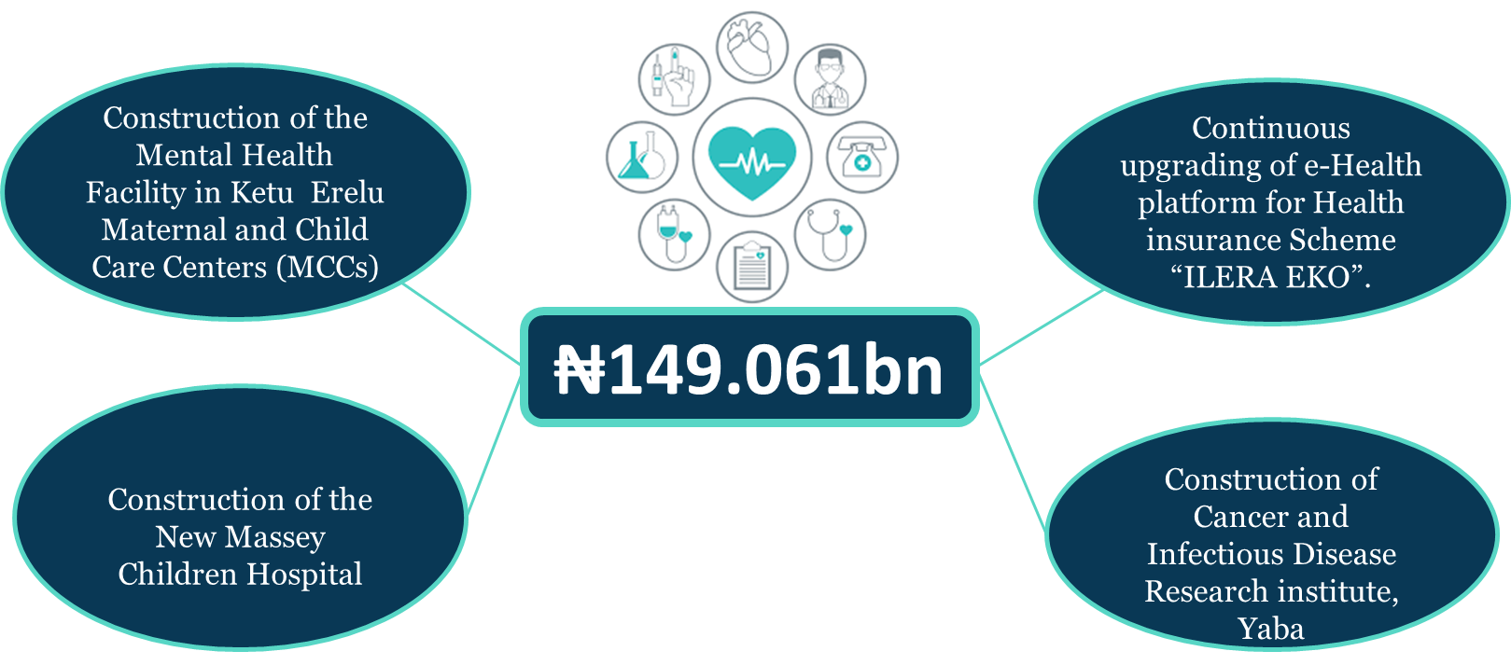

* 1. **Environment**

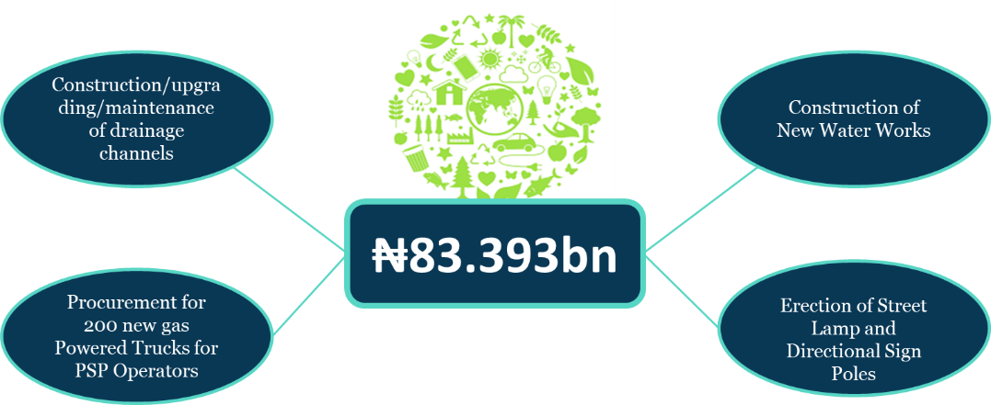The sum of **₦83.393bn** was earmarked for the environment sector for the following projects;

* 1. **Tourism**

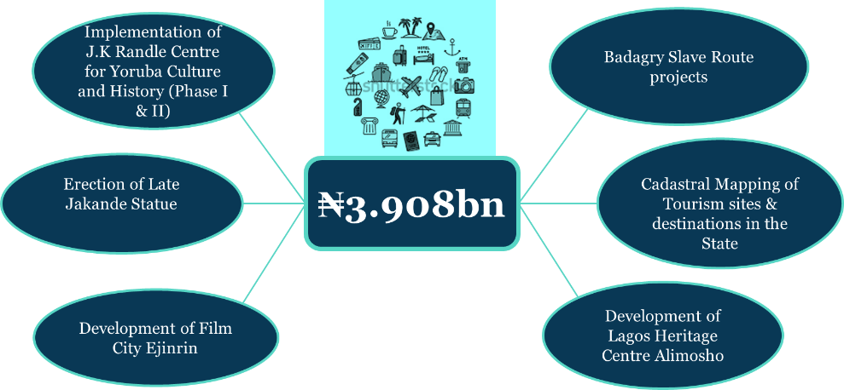The sum of **₦3.908bn** was budgeted for the execution of the projects listed below:

* 1. **Sports Development**

The total sum of **₦12.943bn** has been earmarked for Sports Development in the State.

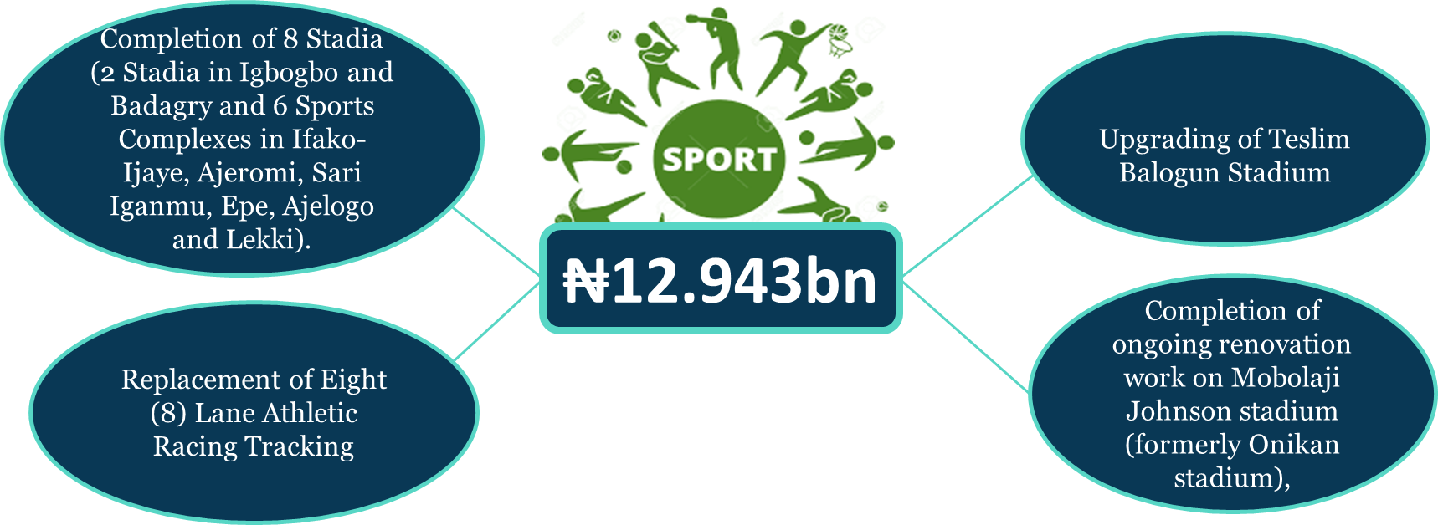

* 1. **Housing and Community Amenities**

The total allocation to this sector is **₦67.130bn**, these include:

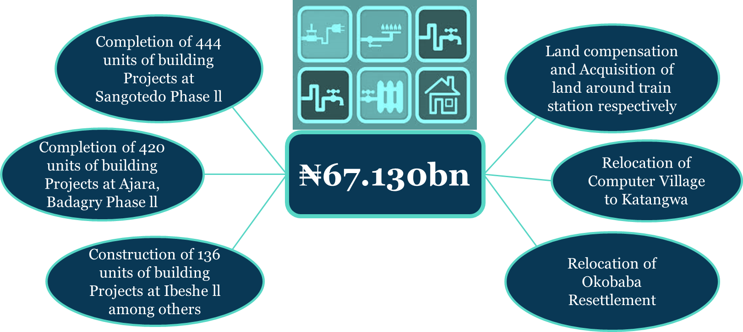

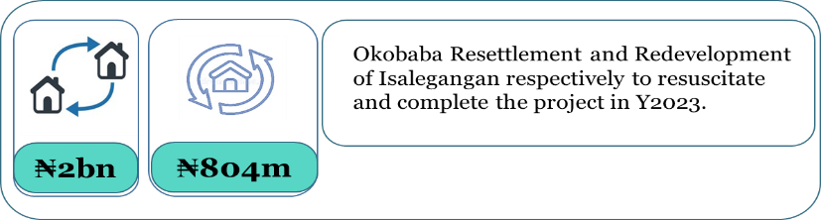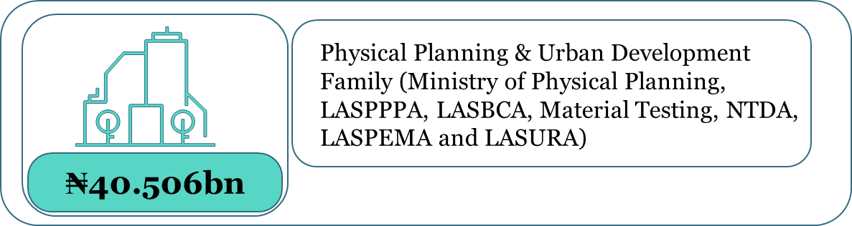

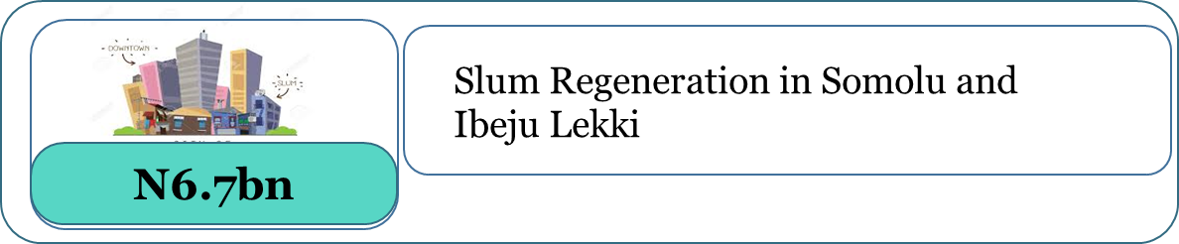

* 1. **Agriculture and Food Security**

A sum of **₦45.133bn** was approved for the Agricultural sector in order it ensure Food Security in the State through:

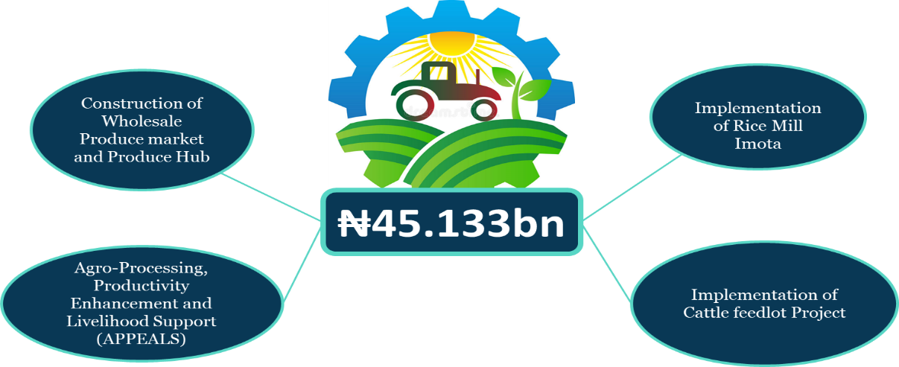

* 1. **Commerce and Industry**

In the area of Commerce and Industrialization, the sum of **N6.068bn** was earmarked for the provision of the following Projects below:

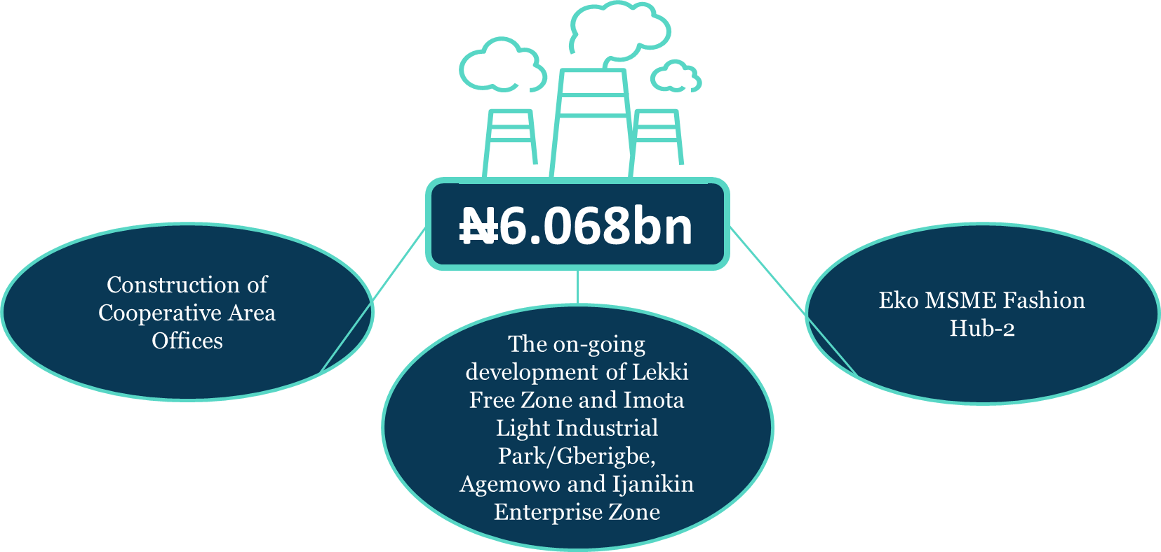

* 1. **Wealth Creation and Employment**

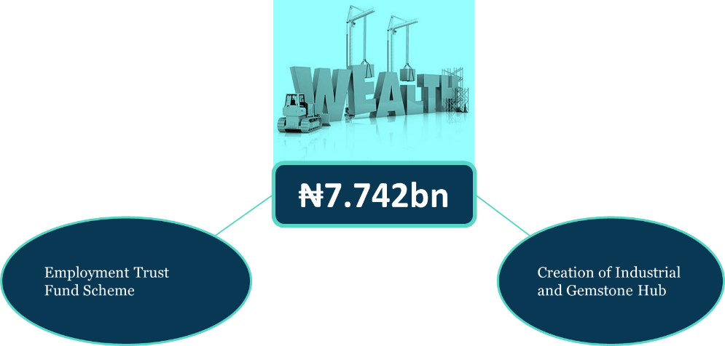The sum of **₦7.742bn** was earmarked in the budget to continually sustain;

* 1. **Women Affairs**

To reduce the Poverty to the minimum level, the needs of women in the State are recognized and has been provisioned for with a sum of **₦4.287bn** to enhance the programs and projects below:

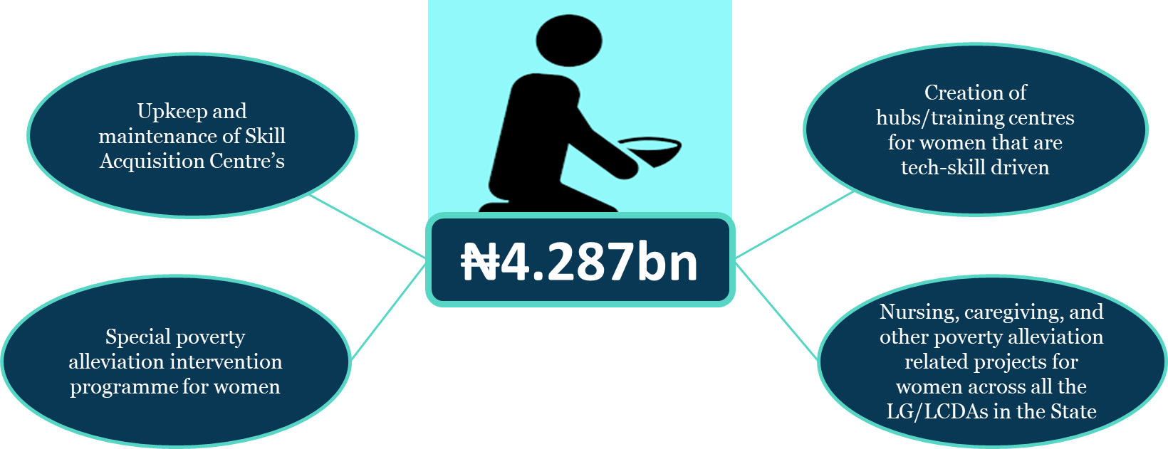

* 1. **Youth and Social Development**

A sum of **₦4.994bn** is to be injected on ensuring a safe pace for youths across the State. The following projects have been earmarked for in Y2023:

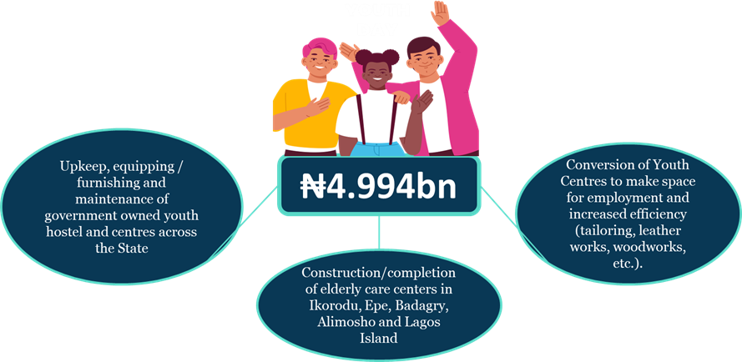

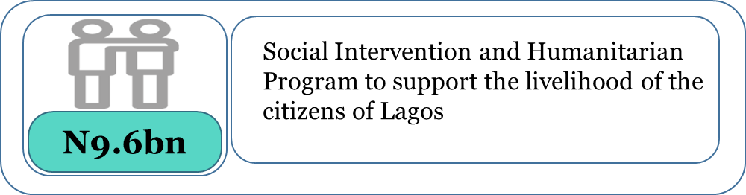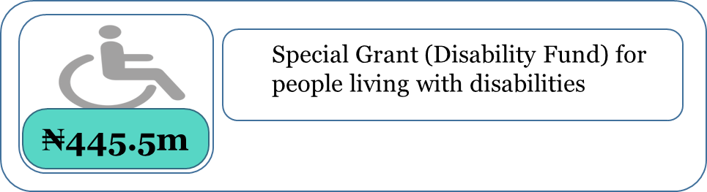

* 1. **Security and Governance**

The total sum of **₦86.816bn** has been earmarked for Public Order and Safety.

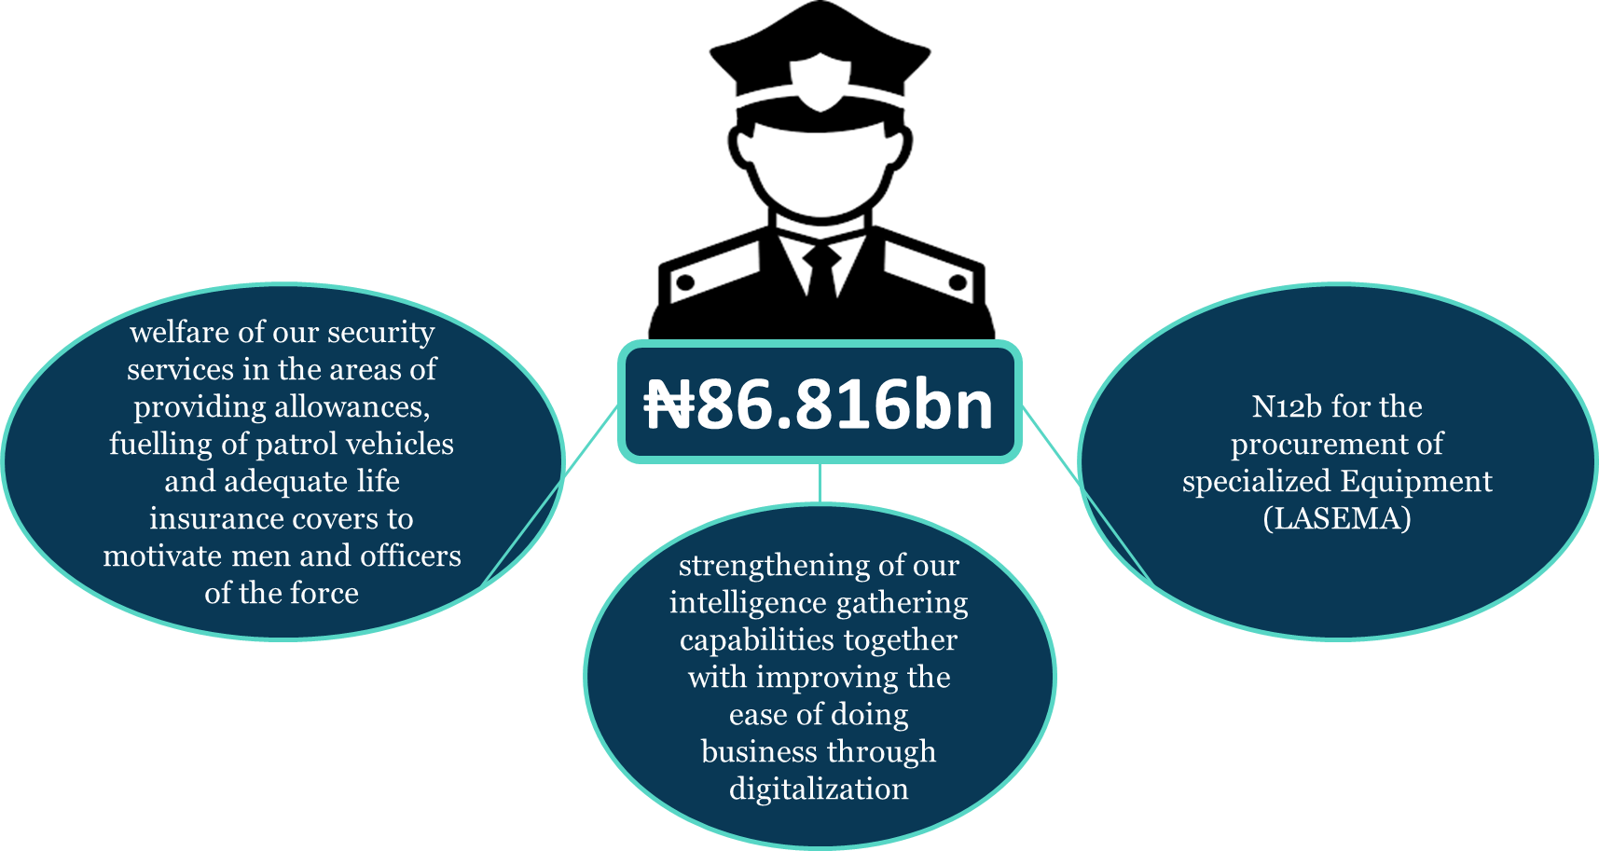

1. **Y2023 Budget Work Plan**

|  |  |  |  |  |
| --- | --- | --- | --- | --- |
| **SN** | **SUBJECT** | **ACTIVITY** | **START DATE** | **END DATE** |
| 1 | Conclusion on Y2022 & Inception of Y2023 Budget | a) Issuance of Y2023 Budget Operational Guidelines | January | January |
| b)Y2023 Budget Analysis | January | January |
| 2 | Budget Performance Appraisal | a) 4th Quarter/Full Year Y2023 Budget Performance Appraisal | January | January |
| b) 1st Quarter Y2023 Budget Performance Appraisal | April | April |
| c) 2nd Quarter/Mid-Year Review of Y2023 Budget Performance | July | July |
| d) 3rd Quarter Y2023 Budget Performance Appraisal | October | October |
| e) Y2023 Budget Performance Appraisal for the 4th Quarter/Full Year | January 2024 | January, 2024 |
| 3 | Implementation of the Y2023 Budget | a) Publishing of Citizens Guide | February 2023 | February 2023 |
| b) Publishing of Abridged Budget Document | March 2023 | March 2023 |
| c) Burning of detailed Budget into CD/hosting on the internet) | March 2023 | March, 2023 |
| 4 | Commencement of Y2024 Budget Preparation | a) Meeting with Major Revenue Generating Agencies and Ministry of Establishment Training & Pensions on Fiscal Strategy 2023-2025 | June 2023 | June 2023 |
| b) Preparation and Adoption of Fiscal & Sector Strategy for 2023-2025 | June 2023 | June 2023 |
| c)Presentation of 2023-2025 Economic & Fiscal Update/MTBF to EXCO/Forwarding to HOA | July 2023 | July 2023 |
| e) Function Group Budget Disaggregation Meeting | July 2023 | July 2023 |
| f) Submission of Function Group agreed with figure | July 2023 | July 2023 |

|  |  |  |  |  |
| --- | --- | --- | --- | --- |
| 5 | Commencement of Y2024 Budget Preparation | g) Budget Consultative Forum | |  |
| i) Ikeja Division | August 2023 | August 2023 |
| ii) Badagry Division | August 2023 | August 2023 |
| iii) Lagos Island | August 2023 | August 2023 |
| iv) Ikorodu | August, 2023 | August, 2023 |
| v) Epe | August 2023 | August 2023 |
| 6 | Preparation of Y2024 Budget Estimates | a) Issuance of Y2024 Call Circular | August 2023 | August 2023 |
| b) Workshop for Planning Officers in MDAs | August 2023 | August 2023 |
| c) Uploading of Budget proposals into the Oracle | August 2023 | August 2023 |
| d) Submission of Budget Proposals | August 2023 | August 2023 |
| e) Evaluation of proposals | August 2023 | August 2023 |
| f) Bilateral Budget discussions | September 2023 | September 2023 |
| 7 | Collation of Bilaterally Agreed Budget Figures | a) Compilation of Revenue, personnel Cost, Overhead Cost, Capital Cost etc. | September 2023 | September 2023 |
| b) Production of Budget summary table | September 2023 | September 2023 |
| 8 | Y2024 Draft Budget | a) Submission for Y2024 Draft Budget to Mr. Governor | September 2023 | September 2023 |
| b) Presentation of Y2024 Draft Budget to the State Treasury Board for Consideration and Approval | September 2023 | September 2023 |
| c) Presentation of Y2024 Draft Budget to the State Executive Council for Consideration and Approval | September 2023 | September 2023 |
| d) EXCO Legislative Parley on Proposed Y2024 Budget | September 2023 | September 2023 |
| 9 | Legislative Processes | a) Presentation of the Y2024 Appropriation Bill to the House of Assembly | September 2023 | September 2023 |
| b) Consideration of the Appropriation Bill by the House of Assembly | October-December 2023 | October - December 2023 |
| c) Passing of Y2024 Appropriation Bill into law by House of Assembly |
| 10 | Appropriation Law | a) Printing of the Appropriation Law | December 2023 | December 2023 |
| b) Assent of Y2024 budget by Mr. Governor | December 2023 | December 2023 |
| c) Updating of Y2024 Approved Budget into the Oracle | Jan 2024 | Jan 2024 |
| 11 | Conclusion of Y2023 Budget | Y2023 Budget Performance Appraisal for the 4th Quarter/Full-year | Jan 2024 | Jan 2024 |

1. **Citizens’ Role**

We appeal to Citizens to cooperate with the State Government through:

* Regular and Prompt payment of taxes
* Timely Provision of information to security agencies
* Monitoring of ongoing Government projects and reporting observed lapses to appropriate Government agencies.
* Patronage and Protection of Public Facilities and Infrastructure

**Budget Department Alausa**

Ministry of Economic Planning & Budget

The Secretariat

Ikeja, Lagos.

E-mail: [mepb@lagosstate.gov.ng](mailto:mepb@lagosstate.gov.ng)

Website: [www.lagosstate.gov.ng](http://www.lagosstate.gov.ng)